Algebraic Expressions- Answers

May 2019 Mathematics Advanced Paper 1: Pure Mathematics 1

May 2017 Mathematics Advanced Paper 1: Pure Mathematics 1

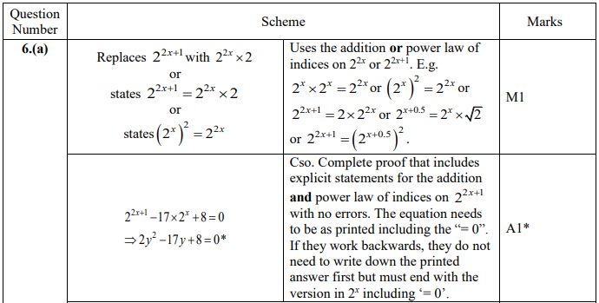

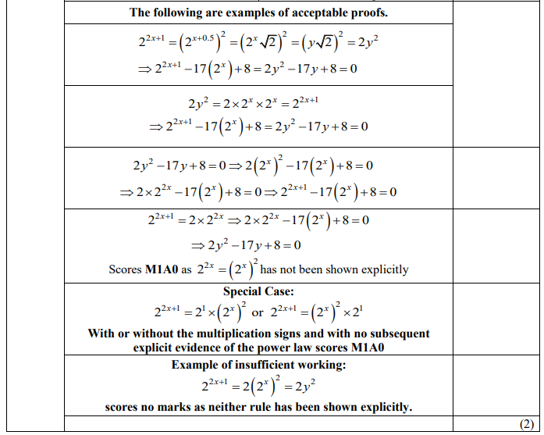

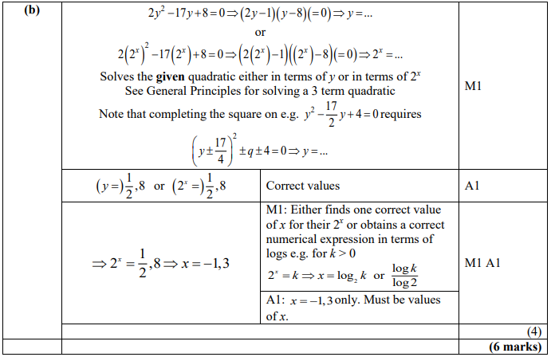

May 2016 Mathematics Advanced Paper 1: Pure Mathematics 1

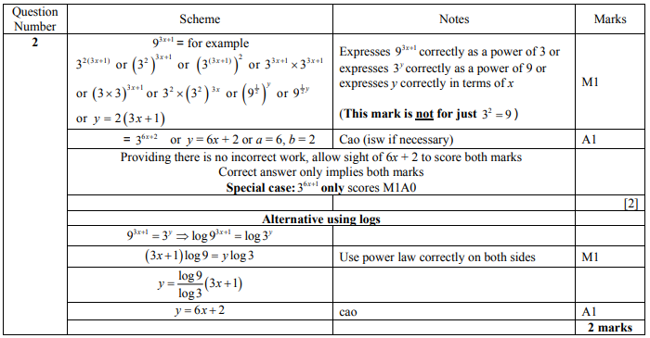

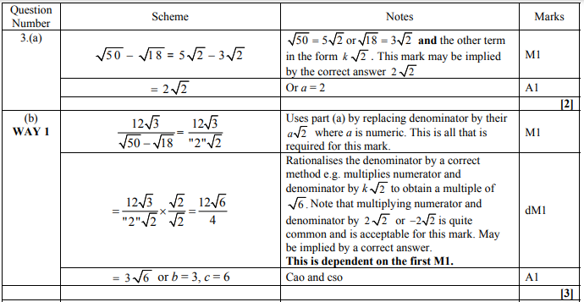

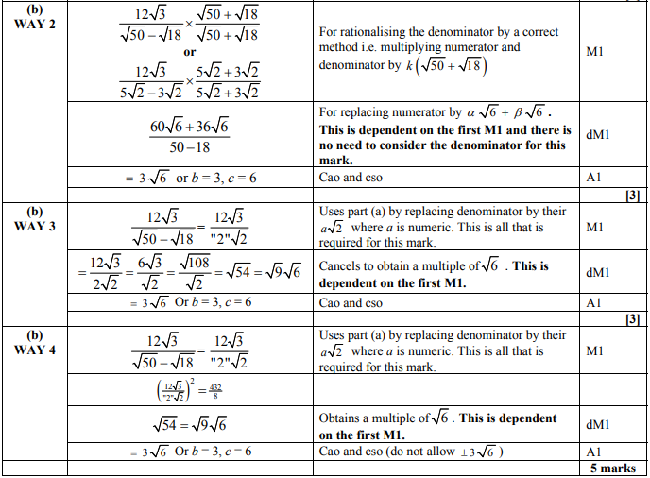

May 2015 Mathematics Advanced Paper 1: Pure Mathematics 1

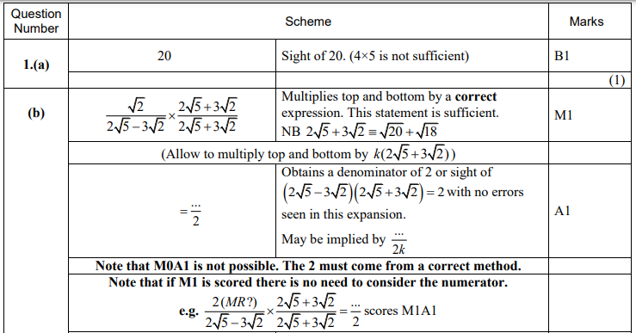

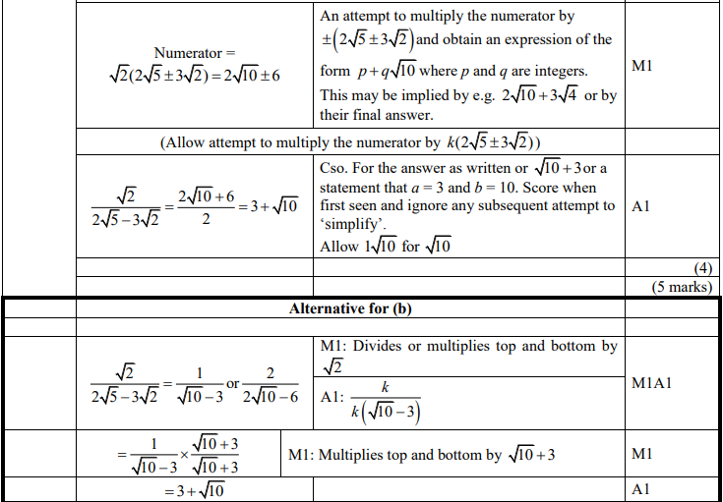

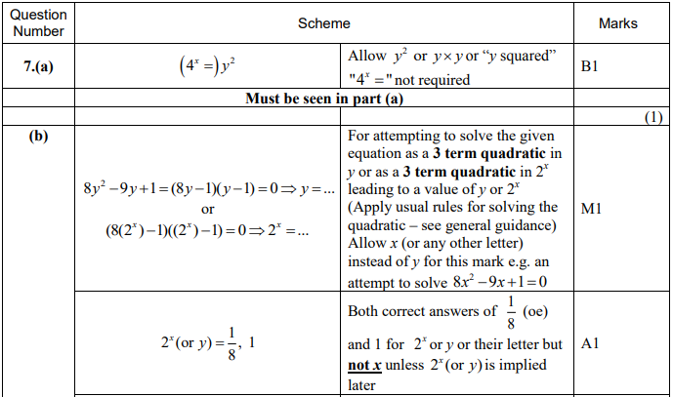

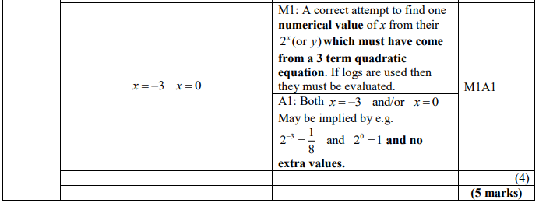

May 2014 Mathematics Advanced Paper 1: Pure Mathematics 1

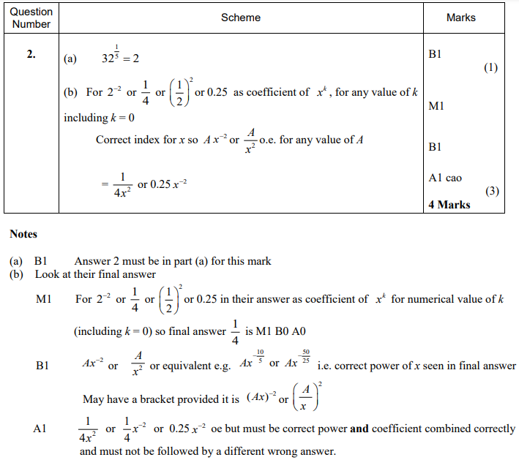

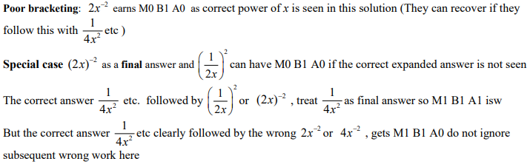

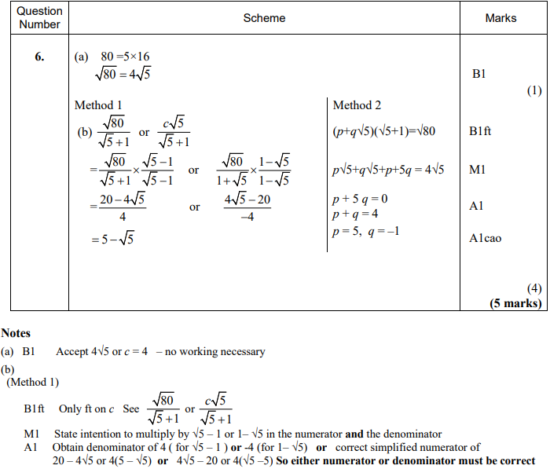



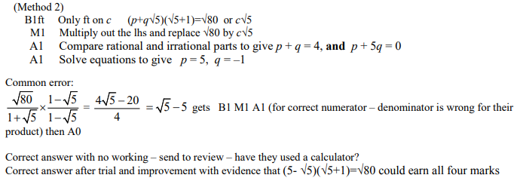

May 2013 Mathematics Advanced Paper 1: Pure Mathematics 1

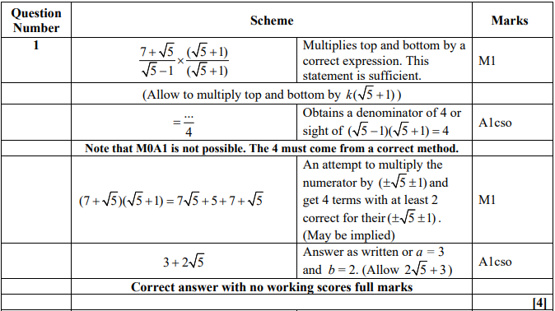

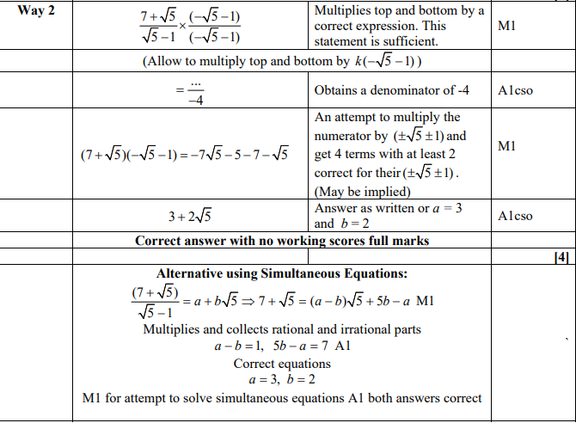

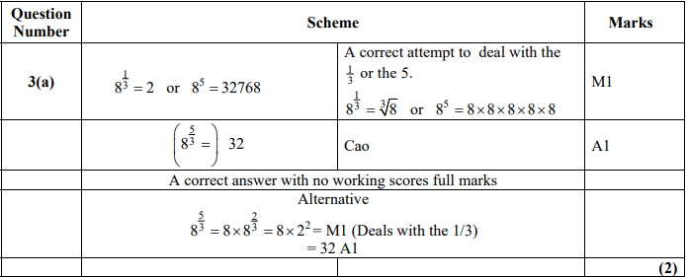

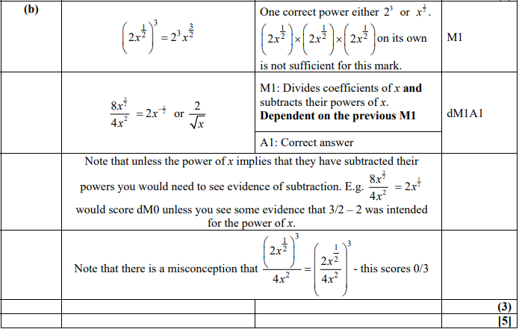

Jan 2013 Mathematics Advanced Paper 1: Pure Mathematics 1

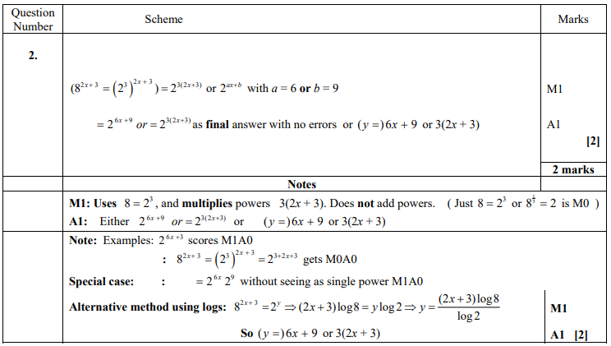

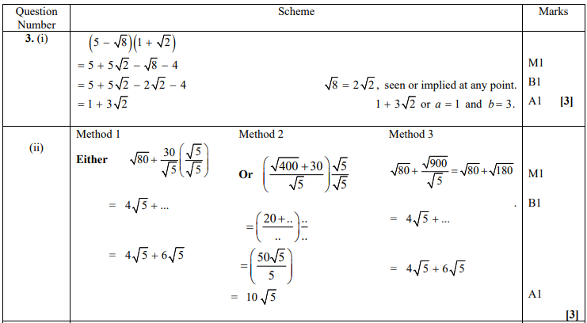

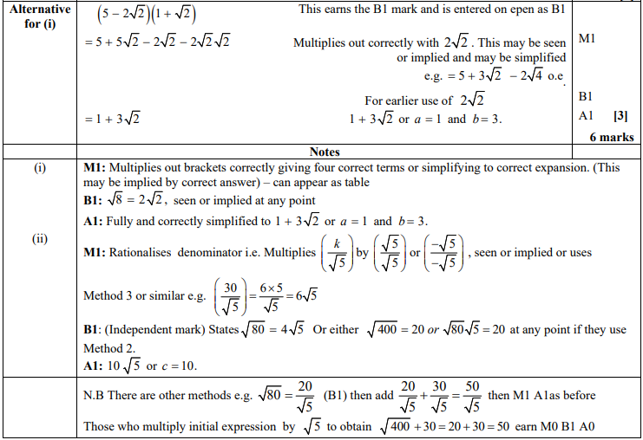

May 2012 Mathematics Advanced Paper 1: Pure Mathematics 1

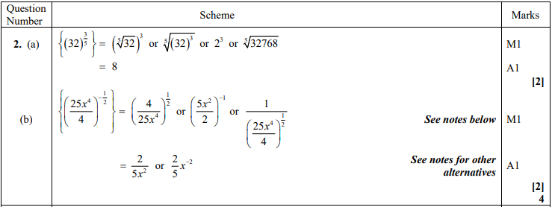

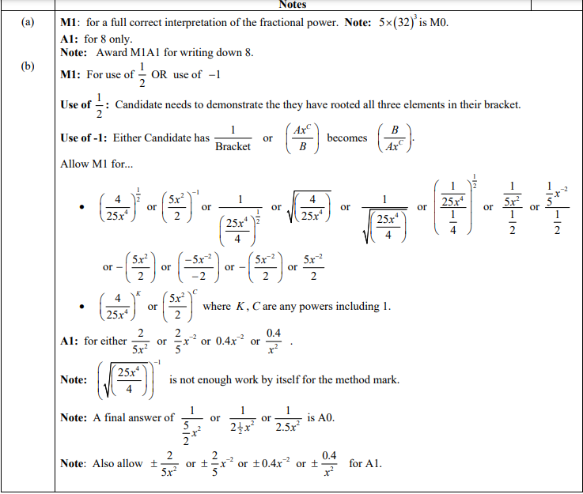

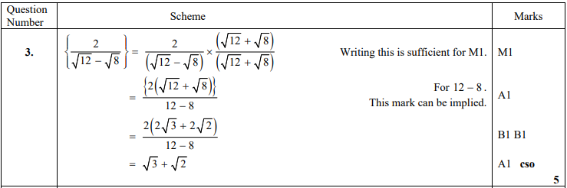

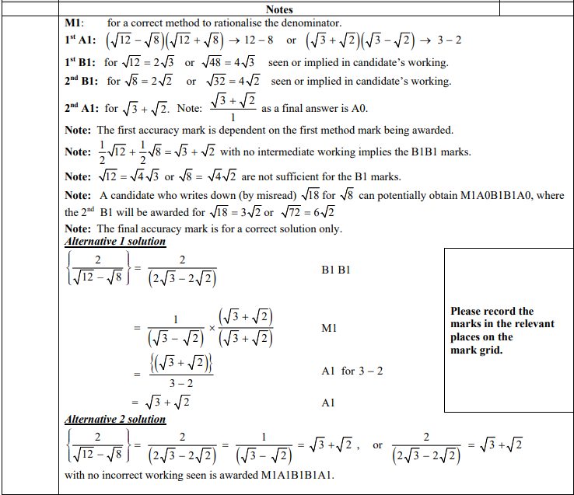

Jan 2012 Mathematics Advanced Paper 1: Pure Mathematics 1

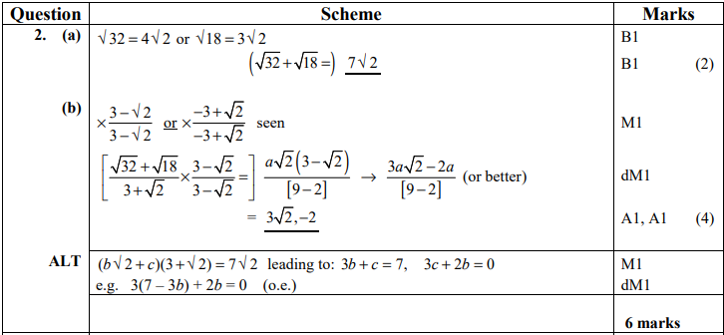

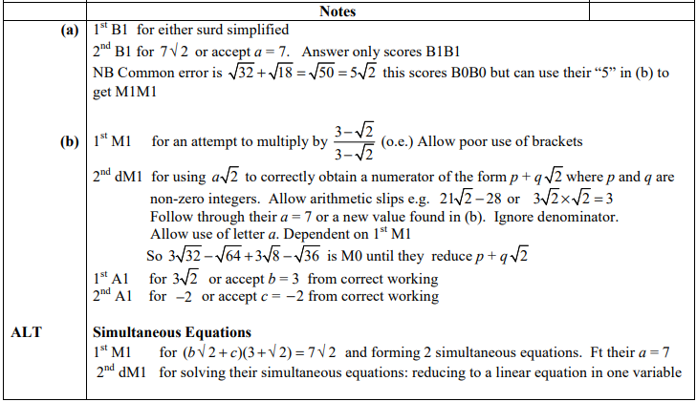

May 2011 Mathematics Advanced Paper 1: Pure Mathematics 1

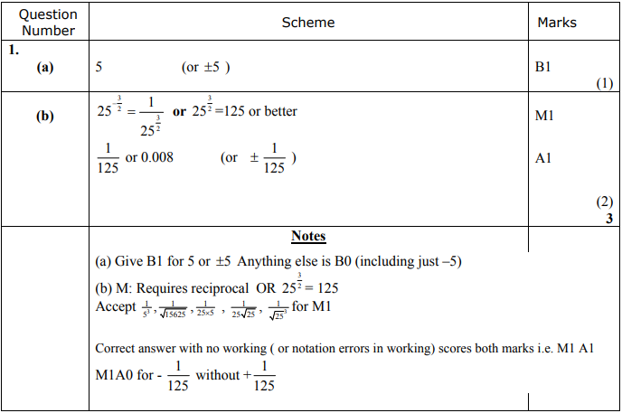

Jan 2011 Mathematics Advanced Paper 1: Pure Mathematics 1

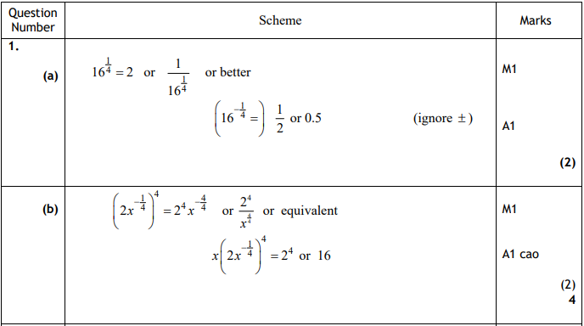

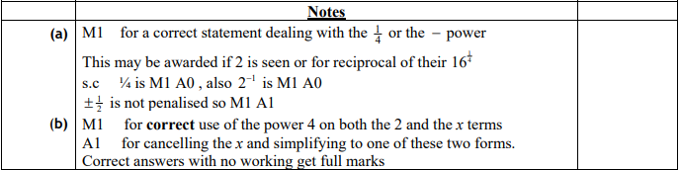

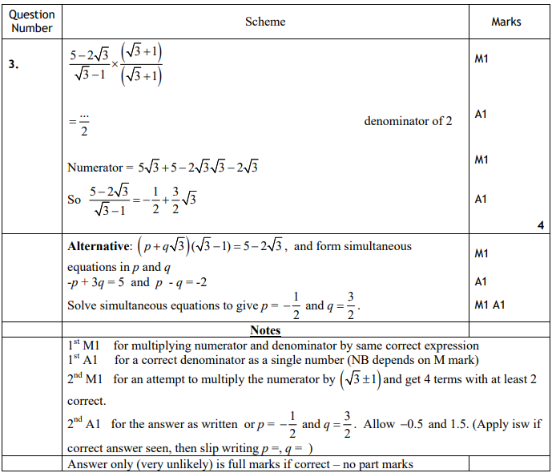

May 2010 Mathematics Advanced Paper 1: Pure Mathematics 1

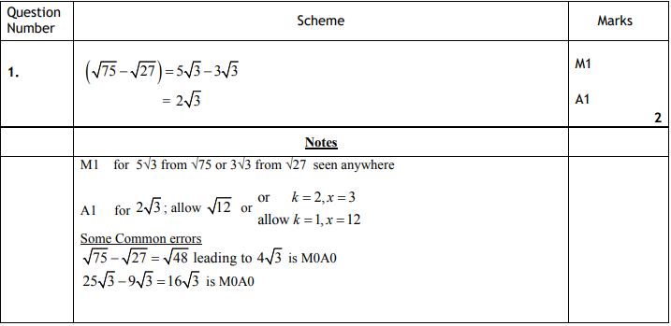

Jan 2010 Mathematics Advanced Paper 1: Pure Mathematics 1

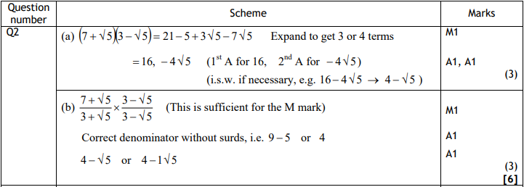

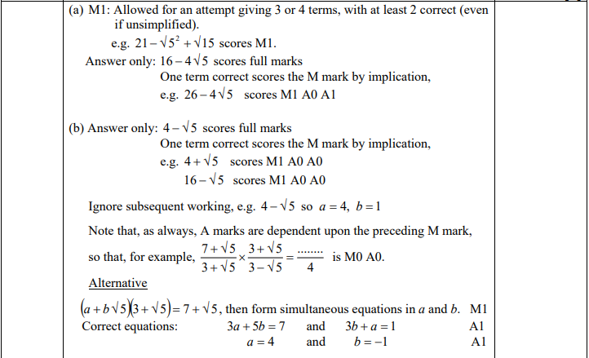



Jan 2011 Mathematics Advanced Paper 1: Pure Mathematics 2

